Online Resources for 1st Grade Students
There are a lot of great free learning resources online that your student would benefit from. Below is a list of some online resources for your 1st grade student. These are resources aside from what teachers are assigning online on the school curriculum. There is much more than what is on this list! Feel free to explore and allow your child to engage in grade appropriate online learning activities.
Websites:
Abcya.com:
An online educational site that includes reading, mathematics, logic, letter learning, and more for grades K-6. This site is aligned with common core state standards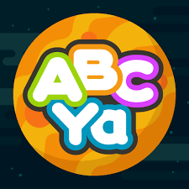
Getepic.com
An online reading resource that students use in school. From the homepage you will click on “Log In” in the top right corner of the screen. Next, you click on students and educators. Finally, you’ll enter the class code under the student login on the left of the page. The class code is: dee9115 Your student’s name will appear and it is leveled to their reading needs.
Storyline Online:
This is an online resource that reads books to kids. Students learn a lot from listening to a fluent reader read a book. Have students watch the videos of stories being read aloud. There is a wide variety of stories to pick from! Pick whatever your student is interested in.

https://sites.google.com/view/learningmathathome/1st-grade-learning-at-home
This is a teacher-created site and has many different mathematical activities to do with your student at home. These activities are aligned with Colorado Standards that your student is assessed on at school. This site is pre-school - 3rd grade with a page dedicated to each grade level. Have fun with the activities!

Play.prodigygame.com
This is a math educational game website. Your student has played this on their school account at school. If your student hasn’t already, they will need to set up an account to play from home! Students really enjoy this math game!

Khanacademy.org
Enjoy an education website that has math and reading material.

Historyforkids.net
This is an educational website for your student to enjoy and learn history. There are tabs for different parts of the world for your student to explore.

Kids.Nationalgeographic.com
This is a great site for your student to explore science content.
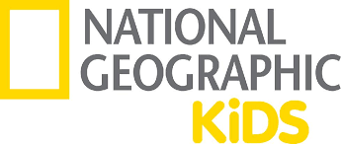

Typingclub.com
This is a website that students can learn how to type on. This website is used at school and your student will be familiar with it.
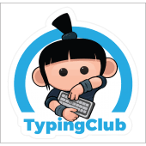
Apps:
Khan Academy Kids:
An educational app that can be downloaded on an iPad, tablet, or phone. This app has thousands of fun activities to help kids learn math, reading, spelling, and more.
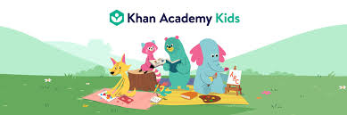

Sight Words Sentence Builder:
An app that gives sight words for your student to make a sentence with. There are levels based on grade levels. Please select level one for your student as that is grade one. If your student completes with ease go ahead to grade two.
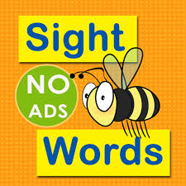
Activities:
There are lots of fun ways to teach your student at home!
- Read a book, but don’t finish it and have your student finish the book. This works on reading and writing skills.
- Act out a book you’ve read from your home and the school curriculum with your student.
- Cook a meal with your student and have your student measure out the ingredients.
- Go on a walk and count how many dogs you see with your student.
- Ask your student what time it is throughout the day.

Thank you for your teamwork throughout this time. Let us know if you have any questions or concerns. We are sending work aside from this list of resources, but this is great for when your student has down time at home.

Sincerely,
The First Grade Team

